Inhoud

Introduction 1

Elaboration of CLI-commands 1

Examples and testing 3

Reporting 5

Statistics 6

# Introduction

Superpy.py is a program by means of which the administration of a supermarket can be kept. The program can accept several kinds op cli (command line interface) commands. A cli command is simply a string of several arguments by means of which the program superpy.py will carry out a specific instruction.

# Elaboration of CLI-commands

As mentioned in the introduction the program allows for a number of CLI commands. These will be discussed underneath mentioning examples of these. Note that any item or value never uses "" or =. It always starts of by py(thon) superpy.py e.g. py superpy.py --h to access the help command or

py superpy.py buy --product-name orange --price 0.68 --expiration-date 2021-01-01

for a buying instruction. Please be concise in formatting your instruction because the instructions are sensitive for hyphens, colons, equal signs(=) and basicly any other reading sign/character. Also stick to the order in which the arguments make up for the instruction. Numbers which have . in common life should be written as such (e.g. 1.00 for prices)

The instructions are :

1.--advance-time x. Running the program with these arguments shifts the

reference day forward by x days. Note that x should be a positive number

because we only go forward in time.

2. buy --product-name xxxxxx --price xxx.yy --expiration-date yyyy-mm-dd.

As you can see there are 6 individual parts in this instruction among which

buy : this is the main part of the instruction which identifies its purpose

buy

--product-name : tag identifying the product name. Should be copied exactly

this way.

xxxxxxxx : any product/item sold by the supermarket such as apple,

orange, milk, bread etc. Please use the single form of the

article.Avoid using e.g. apples, oranges etc.

--price : the price in eur for which the article has been bought by

the supermarket.

xxx.yy : the number for the price of the article

--expiration-date: tag indentifying the expiration date. Should be copied

exactly this way.

yyyy-mm-dd : value for the expiration date (y: year, m: month, d:

day)

Note that the buying date is actually set by the system for this

instruction and equals the reference date registered in the

referred_date.txt file

3. sell --product-name xxxxxx --price xxx.yy

sell : main part of the instruction specifying the instruction type

--product-name : tag identifying the product name. Should be kept identical

xxxxxx : specification of the product name i.e. orange, apple, banana,

coffee, bread etc. Like with the buy instruction please don't use

plural format like apples oranges, bananas etc.

--price :identification of the selling price. Keep this description

identical as specified here.

xxx.yy :specification of selling price in eur. Use a similar format

meaning x as a certain number of digits before the decimal point

and yy as two digits after the decimal point e.g. 1.98

4. report. For reporting three different categories of data are used. All

reporting is displayed by means of tables in the systems console

window (either MS Dos or the Linux system's interface). The

categories are inventory (how much is in stock), revenue (total

amount sold), profit (total amount sold - total amount bought-

total amount perished). In this case for each subsection a separate

subtable is created). The formats of the instructions are :

report inventory --now

report inventory --yesterday

report inventory --date yyyy-mm-dd

report profit --today

report profit --yesterday

report profit date yyyy-mm

report revenue --today

report revenue --yesterday

report revenue --date yyyy-mm

Both the --now and --today values refer to what's taken place so

far today. The program can after all be run on a variety of time

values whereas there may be more purchases or sells made throughout

the day. Notice the inventory can be monitored on any other

specific day whereas the revenue and profit can be computed for any

other month. Notice the profit and revenue are computed for all

products but not separately

5. stats. Stats are computed for all products separately, hence a product

name makes up a part of the instruction. Another contrast compared

to reporting is stats requires a start and end date. The output for

the stats instruction is a bar chart except for profit in which

case it's a line chart. In each case the display has the date on

the x axis. The significance of the y axis depends on the kind of

report which is made.The instruction for stats is specified as

follows :

stats --product-name xxxxx --start-date yyyy-mm-dd --end-date yyyy-mm-dd zzzzzzzzz

stats : principle indication of the report category. Stats stands

for statistics. Statistics means the output will be a

graphical display on the basis of which conclusions can be

drawn

--product-name : identification of the product name. Please keep this

unchanged.

xxxx : specification of the product name ie apple, orange,

banana, milk, bread etc. Please report these products in

single format. Avoid writing apples, oranges etc.

--start-date : identification of the start of the period for which the

graph will be made.

yyyy-mm-dd : value for the start date which should be marked as y

(year), m(month), d(day)

--end-date : identification of the end of the period. Please keep this

unchanged.

yyyy-mm-dd : value for the end date of which the format should be y

(year) m(month) d(day)

zzzzz : this field can have one of the following 5 values. Each

refers to the specific product.

--number :fluctuation of sold numbers on different dates

--buy-price :fluctuation of the average daily price for

which the goods are bought

--sell-price :fluctuation of the average price for which

the goods are sold

--revenue : fluctuation of the daily revenue

--profit : fluctuation of the daily profit

# Examples and testing

Let me start of by stating it’s always a question which character one would like to use for the decimals and what the format of dates should be. In this case the format of the arguments is specified in the English/American way so that’s been left unchanged. However since I’m Dutch I prefer the ,. and the date format dd-mm-yyyy. So these have been implemented in the output. When setting up a project like this one this is actually more work since ,s need to be replaced with . when you want to read date from files and vice versa when you’re creating them. Within Europe in most countries the , is used to indicate decimal places and dd-mm-yyyy or dd-mmm-yyyy for dates. Hence I took the trouble to implement this in the output.

In line with the preceeding paragraph, this paragraph contains a list of examples. The examples are clarified in such a way ideas for testing the functionality are given as well.

In order to start testing it’s recommendable to set the date somewhere in the past e.g. 01-01-2021. This can be done by computing the number of days which have been passed since then and simply set by the command

python superpy.py --advance-time -x

This reference day is registered in the file referred_date.txt. The test should be carried out in such a way that from that day on the day is only shifted forwards. Reporting can of course be done with reference to a month or a date from the past.

Logically the next step is filling the inventory by means of buy instructions though for testing purposes it’s possible to try to sell products which have never been in stock or alternatively products that aren’t in stock because the products which have previously been bought are all sold or expired.

py superpy.py buy --product-name orange --price 0.68 --expiration-date 2021-01-15

Ok

py superpy.py buy --product-name pear --price 0.70 --expiration-date 2021-01-14

Ok

py superpy.py buy --product-name coconut --price 2.50 --expiration-date 2021-03-01

Ok

py superpy.py buy --product-name melon --price 0.55 --expiration-date 2021-01-20

Ok

py superpy.py buy --product-name milk --price 0.95 --expiration-date 2021-01-15

Ok

py superpy.py buy --product-name yoghurt --price 0.88 --expiration-date 2022-01-20

Ok

When you've done this, check the spreadsheet bought.csv. Explication of this file is as follows :

column 1 : Unique purchase id

column 2 : Product name

column 3 : Purchase date (equals reference date registered in referred_date.txt)

column 4 : Price for which the item was bought

column 5 : Expiration date

column 6 : either N when the item hasn't been sold or the date on which the item was sold

After having done this sell a couple of items using the following instructions:

py superpy.py sell --product-name orange --price 0.75

Ok

py superpy.py sell --product-name pear --price 0.80

Ok

py superpy.py sell --product-name coconut --price 2.80

Ok

py superspy.py sell –product-name gold –-price 1000

ERROR. Not in stock

Check the selling date really gets filled in the bought.csv file according to the instructions you gave. After each selling instruction the file sold.csv gets appended. The explication of the columns in this file is as follows :

Column 1. Unique selling id

Column 2. Related buying id

Column 3. Product name

Column 4. Selling date in dd-mm-yyyy

Column 5. Price for which the product got sold

Column 6. Price for which the product got bought

## Reporting

Now after the first buying instruction has been carried out, the inventory should be raised. In order to check the inventory use one of the following CLI's :

py superpy.py report inventory –-now

py superpy.py report inventory --yesterday

py superpy.py report inventory --date 2021-01-01 (or an alternate date)

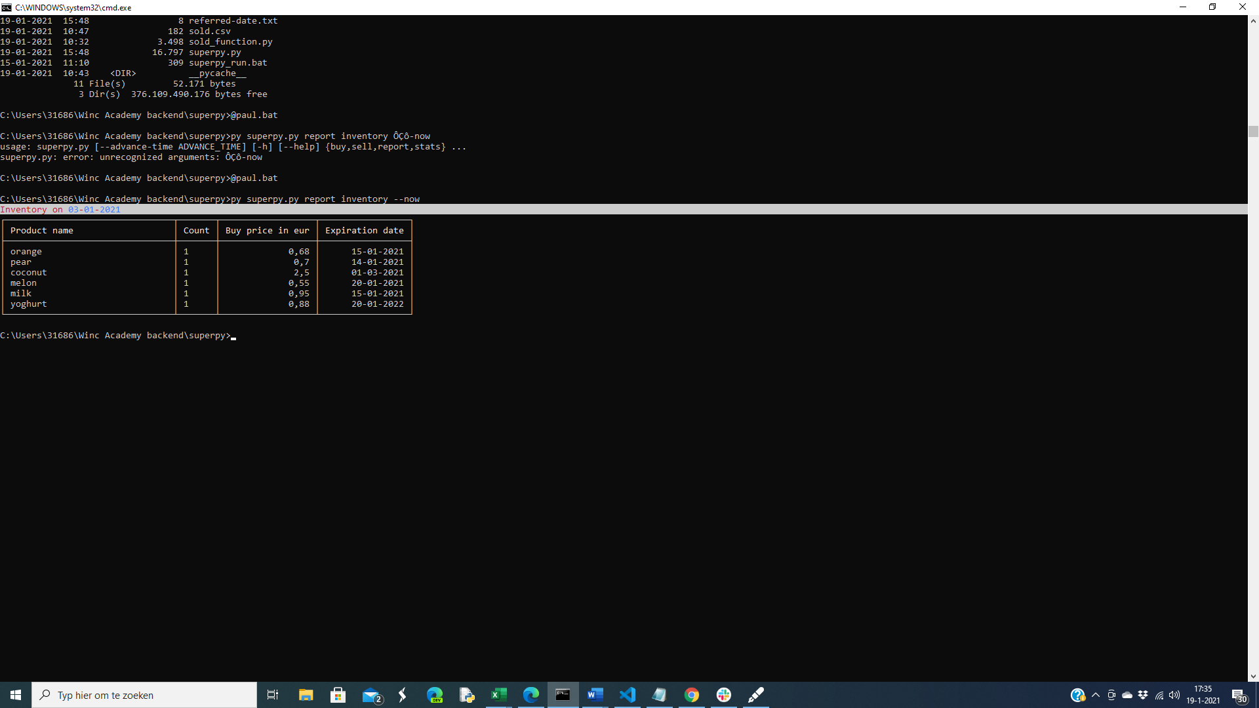

BTW. Pardon for the small display.I used copy screen to display it.

Also immediately the revenue can be checked. In order to do this use one of the following instructions :

py superpy.py report revenue --today

py superpy.py report revenue --yesterday

py superpy.py report revenue --date 2021-01 (notice in this case the month is used where as for the inventory the date is used with a day)

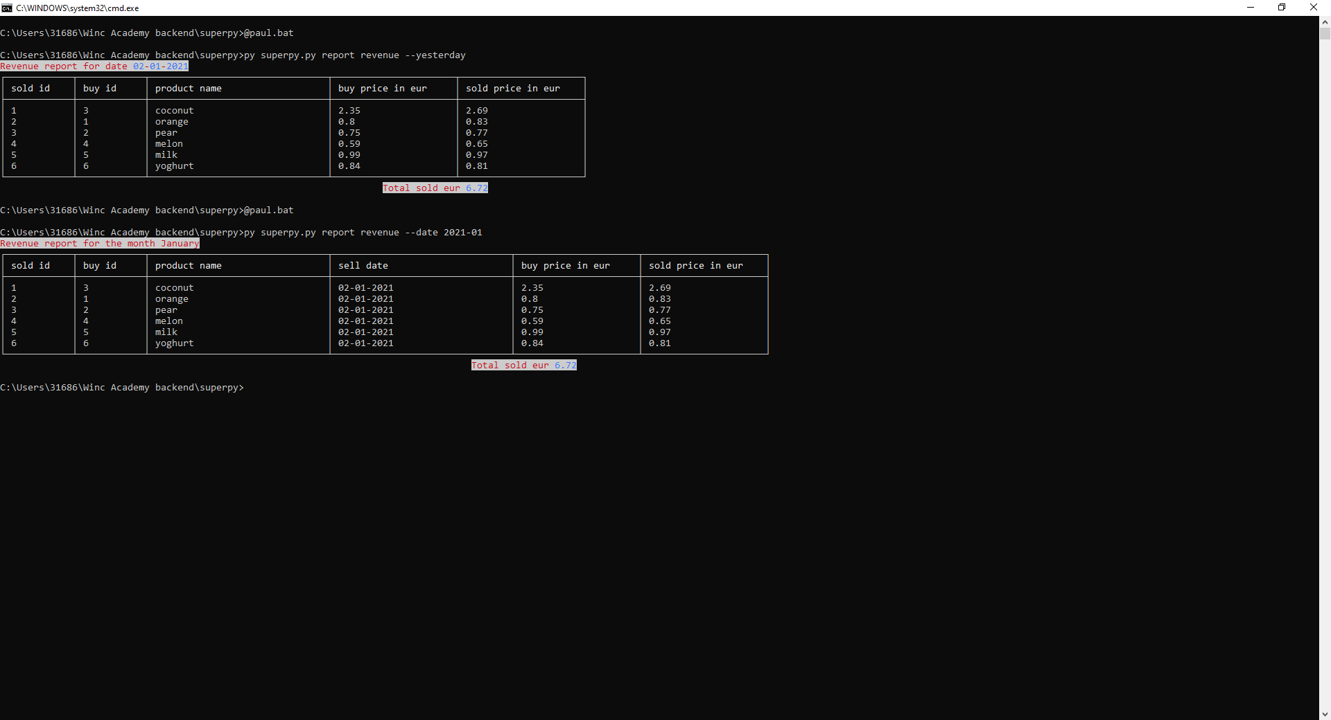

When the revenu is listed for a month period a column for the selling date is added.

It's also possible to check the profit.

py superpy.py report profit --today

py superpy.py report profit --yesterday

py superpy.py report profit --date 2021-01 (notice whichever option is used, the calculation of the profit always entails the calculation of the revenue as well as the computation of purchases and loss due to decay/expired products). Technically it means there’s no duplication of code.

In case there are no sales or purchases taking place on a certain day or in a certain period, rather than showing an empty table, a coinciding remark will be given such as there are no sales for the month/date e.g. January/03-01-2021 (the slash indicating one or the other but not both).

## Statistics

In all cases the x-axis refers to the date. When the numbers of days is restricted. Matplotlib plots the time as well. At first glance this is confusing. No effort has been put into it to clarify this. Overall the impression with statistics for the supermarket if the number of days is not restricted to a number which is smaller than 10. Matplotlib does computations on the representation of data. That was one reason why I didn’t bother to try to convert the price/profit/revenue data here. These data are unfortunately still presented with a . as decimal point though it should be possible to present these data with a colon as decimal point as well (representation could be independent of computation).